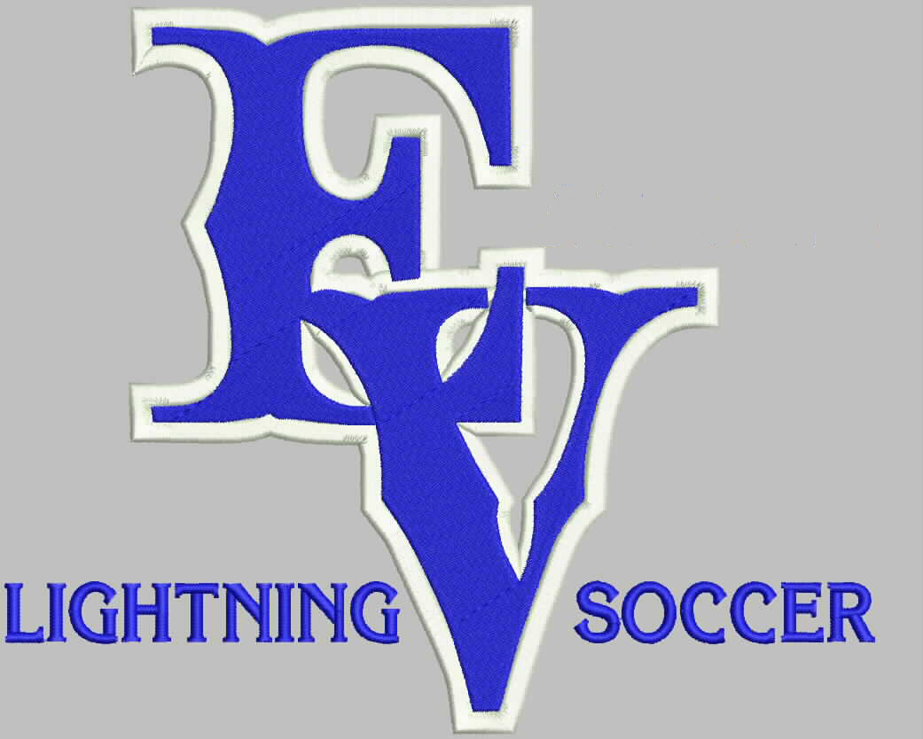
You’re invited!
  - 2013 Alumni vs. Varsity Game and All Team BBQ
Come and watch fun soccer matches
Meet other parents & coaches
Enjoy a BBQ following the games,
Courtesy of the Lightning Soccer Booster Club
Where: EVHS Soccer Fields & Pavilion
When: Tuesday, August 20th at 5:00
3:00-4:30 9th/10^{th/}JV teams mini tournament
5:00 Alumni vs. 2013 Varsity game
What to bring: Freshman – Chips
Sophomores – Water
Juniors – Bars or cookies
Seniors – paper plates & napkins
*Please bring all contributions to the Soccer Pavilion

